A Warm Welcome and an Introduction to the Village of Torworth

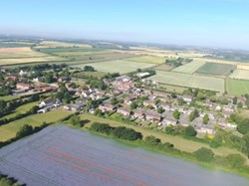

Greetings!
We hope you find this information pack useful and wish you all the very best in your new home.
Torworth village is small with around 200 residents, a fun packed park, allotments and a joint cemetery. We have numerous attractive country walks particularly the new 'Millennium pathway', Daneshill Lakes Nature Reserve. Our community is a very much valued asset.

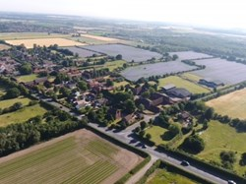
A brief history:

Torworth pronounced 'Tor-erth'
Torworth is a small village in the Bassetlaw district of North Nottinghamshire, sitting on the old Great North Road and approximately 5 miles from the Town of Retford.
The village lists many historic interests, being mentioned in the Domesday book as 'Turdeworde' with visible remains of an 11th century moat.

The origins of the settlement of Torworth, are pre-Roman, and it contains a number of designated heritage assets. Notably, there are three listed farmsteads (Manor, Poplar and Moat Farms) within 300m of the Site. These are clustered around the historic core, and the southern end of the settlement. Other designated heritage assets are found to the north of Torworth, on Blyth Road, and to the west at The Mantles.

MANOR FARMHOUSE
An early 19th Century farmhouse located in between Great North Road and Low Street. It is rendered with hipped slate roofs supported on wooden eaves brackets, with an eaves band

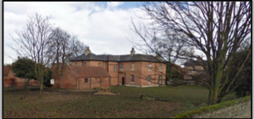
POPLAR FARMHOUSE
This too, according to Historic England’s Register is an early 19th Century farmhouse. According to the Register:
It is rendered brick with a slate roof. To the rear, there are two rendered stacks and a deep overhang to the eaves.
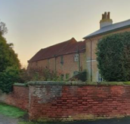

MOAT FARMHOUSE
Described within the Register as an early 19th Century farmhouse, and constructed in red brick with a pantile roof, with single left gable stack and dentillated eaves.

The Village Boundary

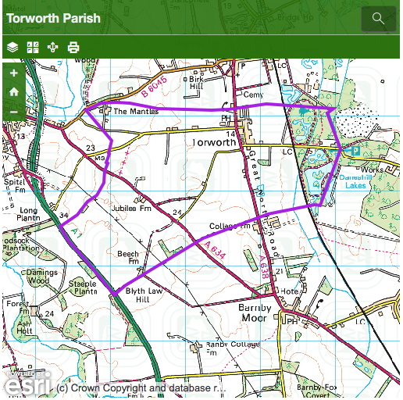

Local Amenities

Torworth Village Park
The village park is a well-equipped play and leisure facility situated on Holds Lane. It is owned by the village and is funded and maintained by Torworth Parish Council who have an ongoing scheme of refurbishment of existing equipment and re-development of the park area to make it more appealing and accessible to residents of all ages.

Torworth Grange Farm Shop, Café Restaurant and Lakes
The Farm Shop stocks a great range of fresh produce, from meat and vegetables to bread and cakes, as well as showcasing specially selected ranges of local and national products.
Torworth Grange Farm also boasts a Café Restaurant which serves a delicious selection of breakfasts, home cooked meals as well as light bites and freshly made cakes meaning there will always be something to tempt your fancy.
The Farm Shop is situated on the Great North Road within the Village itself.
Full details can be found at www.torworthgrange.co.uk

Retford Gymnastics Club
Torworth
The Old Timber Shed
Torworth
DN22 8JZ

Millennium Pathway
The STAR Millennium Pathway is a common link between the villages of Scrooby, Torworth and Ranskill. It was developed in partnership with Nottinghamshire County Council and funded with a grant from the Heritage National Lottery Fund. It offers accessibility in places for wheelchair users and is a lovely walk along which much wildlife can be seen.

National Trust - Clumber Park
Only a short drive from Ranskill is Clumber Park, owned by the National Trust, which is a former home to the Dukes of Newcastle-under-Lyme and provides 3800 acres of beautiful parkland, which can be used for walking, cycling or as a lovely venue for picnics and barbecues.

Idle Valley Nature Reserve
A spectacular wetland site that covers an area of 450 hectares following the River Idle northwards, it is one of the largest sites for nature conservation in the East Midlands. It is supported by a grant from the National Lottery through the Heritage Lottery Fund and is well worth a visit.

Blue Bell Public House - Ranskill
The Blue Bell is at the centre of the village on the Great North Road. It is a thriving village pub with excellent beers and wines and superb home-cooked food. Live musical entertainment and quizzes are popular features and Sherry and Steve offer a warm welcome to both locals and travellers so come and visit!

Mobile Library - Ranskill
Once a month, usually towards the end, a mobile library operated by Nottinghamshire County Council visits Ranskill and stops in the following places: Southfall Close 10.40; Arundel Drive 1 11.00; Arundel Drive 2 11.45; Blyth Road (West End House) 12.10; Station Road 12.25; Station Avenue 1 13.40; Station Avenue 2 (No. 57) 14.00. Further details can be obtained on the Nottinghamshire County Council website or by looking in The Star newsletter each month.

Post Office & General Store - Ranskill
The Post Office & General Store, called the Top Shop, can be found at the junction of the Great North Road and Station Road in the centre of the village. It provides a handy range of food, drink, stationery and postal facilities. Please ensure that you park responsibly and do not block the approaches to the busy five-way junction.

Fish & Chip Shop - Ranskill
Ranskill boasts one of the best fish and chip shops in the area. The chip shop is situated next door to the Post Office & General Store at the top of Station Road - please park responsibly and have consideration for other road users.

HEALTH AND COMMUNITY FACILITIES
Torworth is served by the Bawtry & Blyth Medical which is located approximately 2.5 miles from the village.

Clubs and Societies

Little Owls Baby & Toddler Group - Ranskill
The Baby & Toddler Group meets in the Nursery at Ranskill Primary School every Tuesday between 3.30pm and 4.30pm. Further information can be obtained from Karen Meakin or Rachael Clayton on 01777 816066 or by emailing ranskillnursery@gmail.com

Nottinghamshire Wildlife Trust (Retford Group)
The Retford Group of Nottinghamshire Wildlife Trust meets every second Thursday evening of the month
during the winter. For further details, please contact Jan Williamson at janwilliamson5@icloud.com

Friends of Daneshill Lakes
Daneshill Lakes are located on the outskirts of Torworth village. The lakes and nature reserve
are an enjoyable place for walking, bird watching, fishing or just for some quiet time. Further details can be
obtained from the Secretary, Mrs Lesley Noar, by calling 01777 818362 or email daveandlesnoar@outlook.com
There is also a website for further information at www.friendsofdaneshilllakes.btck.co.uk

Ranby Rascals – Ranby House Prep School, playgroup open to all
Wednesdays 8.45-11.30am suitable for 0-5yr olds
A friendly group
Performing Arts Centre, Ranby House School

St. Barnabas Church

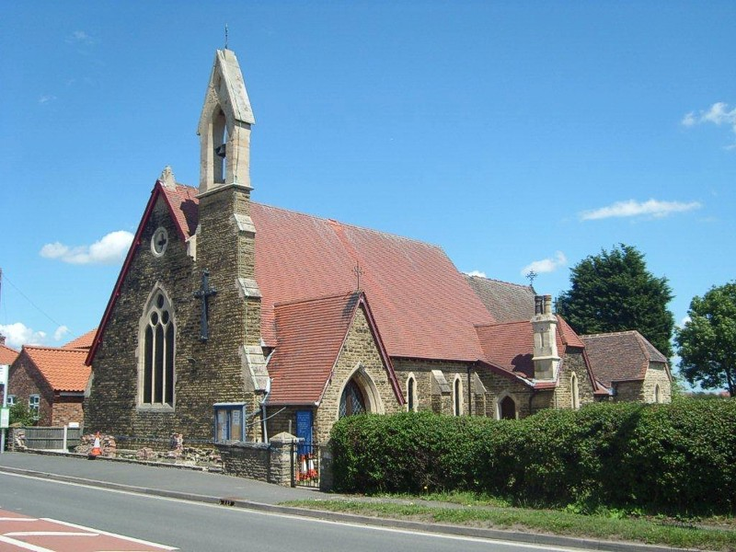

Services are held at 9.30am each Sunday, except where there is a 5th Sunday in the month when we meet at St. Wilfrid’s Church, Scrooby.
On the first Sunday in the month we hold a lively All Age service with children’s activities and light snacks followed by a short service of worship. There is time after all our services to stay for tea or coffee and get to know people – newcomers are especially welcomed.

A thriving Mums and Tots group meet in the church each Monday (except Bank Holidays) from 9.30am to 11.30am and there are lots of toys and activities to keep young children occupied while giving Mums a chance to chat over a coffee.

An informal Singing Group meet in church every other Tuesday evening from 7pm. Everyone is welcome; there are no auditions and you just have to enjoy singing.

Mothers Union also meets at St Barnabas Church on the second Wednesday of the month but times can vary between 2pm and 7pm so please consult The STAR each month where the time of any forthcoming meeting is published.

A busy Messy Church meets at 3.45pm on the second Thursday of the month with lots of activities for children and their parents/carers. There is a short service of worship followed by a hot meal for families to share.

Once a month, usually the third Thursday, Lunch Club meets at 12.30pm. Everyone is welcome to join in a sociable couple of hours and to share a simple three course lunch for a very reasonable charge.

Fayres are held at the Church at Christmas and during the summer and there are other social events held throughout the year.

The Church has a well-equipped kitchen and is available to hire for parties, meetings etc, at very reasonable rates. Details can be obtained from the Churchwardens.

You don’t have to be a member of our Church to attend any of the above activities.

Church Wardens: Dave Hill 01777 818072 / David Stacey 01777 818303
EDUCATION
Ranskill Primary school is the closest school to the Site being located 0.6m to the north (roughly a 3-minute drive and 20-minute walk). There also exists the Primary School of St Mary & St Martin Blyth which is a 5-minute drive and accessible by bus.

There are several secondary schools in the surrounding areas all of which are within a relatively short drive and are accessible by public transport. The nearest secondary schools include Serlby Park Academy, Retford Oaks Academy, and Elizabethan Academy Retford.

Ranskill Primary School


Cherry Tree Walk, Ranskill, Retford, DN22 8LH
Telephone: 01777 818468 Email: administration@ranskill.notts.sch.uk
School Phase: Primary; Area : Bassetlaw; Number of Pupils: 107; Age Range: 5 to 11

Is a small, but growing, village school. We pride ourselves on our warm and friendly atmosphere. Our children work hard and achieve good results and the staff are dedicated to helping all our children achieve to their full potential. We have strong links with the local community and have an ‘open door’ policy, welcoming parents and members of the local community into our school. We have a thriving PTA which supports the school by organising a wide variety of events and activities. We offer a range of after-school clubs, such as Chess, kick boxing and craft club. We have a weekly mentions assembly to which parents, grandparents and friends are invited to help us celebrate the achievements of our children.
We share our school site with Ranskill Nursery. The nursery occupies a new, purpose-built building which was opened in February 2011, superbly equipped and catering for children from 2 to 5. The strong working relationship between nursery and the school means that children are able to make the transition from one to the other with relative ease. A 10-day transition process helps the children feel at home in the school before they start with us full time.
We work very closely with other local schools, having, for example, joint sports, maths and science activities. We often visit the Elizabethan High School in Retford, to where most of our children transfer for their secondary education.
Choosing the right school for your child is a very important decision. We strongly feel that the right place for the children in our catchment villages is with us at Ranskill Primary School. If you are looking for a school, then please come and visit us, we would be more than happy to show you around and give you the opportunity to meet our staff and children and learn more about us.
Stuart Moody - Head Teacher
email: headteacher@ranskill.notts.sch.uk
please visit the website at: www.ranskillprimary.co.uk
The STAR Magazine

The STAR is the monthly magazine covering the North Nottinghamshire villages of Scrooby, Torworth and Ranskill whose initials give rise to the acronym 'STAR'.

The magazine was first printed in 1984 and is produced monthly by a hard-working team of volunteers from all three villages. It is now an irreplaceable news asset which regularly features 40 pages of interesting and relevant articles and is distributed FREE to around 1,000 homes in the STAR villages nestling along the route of the old Great North Road. The STAR can be read on line at the-star.org.uk

The re-birth of the village website will enable The STAR to reach a potentially global audience – and will be accessible to former residents of Scrooby (the home of the Pilgrim Fathers), Torworth and Ranskill.

All articles for publication should be submitted as soon as possible but no later than the 16th of each month.

To view previous issues of The Star, please visit www.the-star.org.uk

Bus Routes

The settlement is well served by public transport in the form of bus routes, with, 6 different routes running hourly through Torworth.

These bus routes include:
- 29: Retford to Doncaster
- 99: Retford to Doncaster
- 595: Bawtry to Gainsborough
- 689: Retford Bus Station to Cantley, Mcauley School
- Doncaster Shopper: Tuxford to Retford to Doncaster
- ROA2: Wiseton to Retford

Bus Stops in Torworth:
Old School House, Great North Road (both sides of the road)
Blacksmith Lane (both sides of the road)

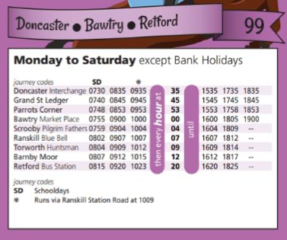

595 - Bawtry - Gainsborough Bus Route:
Bawtry -> Gibbet Hill -> Scrooby -> Ranskill -> Blyth -> Torworth -> Barnby Moor -> Retford -> North Wheatley -> Sturton le Steeple -> Bole -> Saundby -> Beckingham -> Gainsborough -> Morton
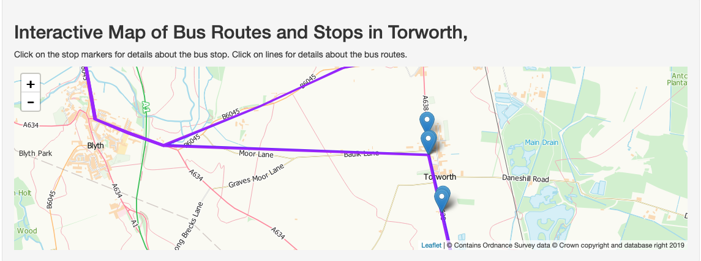
Torworth Parish Council Contact Details

Torworth Parish Council website address: www.torworthvillage.co.uk

Torworth Parish Council Clerk Contact:
Mrs Claire Challener
Grove Farm
101 Town Street
Lound
DN22 8RX
Tel: 01777 816952

To report a Police crime online :
https://www.nottinghamshire.police.uk/do-it-online/report-online

To report Fly Tipping online:
https://selfservice.bassetlaw.gov.uk/renderform.aspx?t=42&k=CE8AED488ED662491EA36EB00C304B99E1B3C01C

To report a street light defect online: https://forms.nottinghamshire.gov.uk/en/AchieveForms/?form_uri=sandbox-publish://AF-Process-9ff5cac9-92c8-4d5f-8a4c-9bfce801e55c/AF-Stage-f12d8315-760d-4e8f-81d4-0af826f8f6f9/definition.json&redirectlink=%2FService%2FServiceRating%3Fserviceid%3DAF-Process-9ff5cac9-92c8-4d5f-8a4c-9bfce801e55c%26service%3DR4%26postRatingRedirectUrl%3D%2Fmodule%2Fservices&cancelRedirectLink=%2F&category=AF-Category-91503628-deb8-4311-82e3-228ca2956156

To report a Pothole online:
https://forms.nottinghamshire.gov.uk/en/AchieveForms/?form_uri=sandbox-publish://AF-Process-b824ccbe-8474-4f8b-b988-13a5c2e6197c/AF-Stage-a3cddfbe-da52-48f6-ad15-8672d9fa4e79/definition.json&redirectlink=%2FService%2FServiceRating%3Fserviceid%3DAF-Process-b824ccbe-8474-4f8b-b988-13a5c2e6197c%26service%3DR4%26postRatingRedirectUrl%3D%2Fmodule%2Fservices&cancelRedirectLink=%2F&category=AF-Category-91503628-deb8-4311-82e3-228ca2956156

To report other Road or Pavement issues online:
http://www.nottinghamshire.gov.uk/transport/roads

To report Dog Fouling (supporting evidence recommended):
Telephone: 01909 533 399 or Email: dogpoo@bassetlaw.gov.uk

For Dog Warden related issues - Telephone 01909 533 219

To report a missed Bin (refuse) online:
https://selfservice.bassetlaw.gov.uk/renderform.aspx?t=6&k=DD0802FCB7D29473AD0E3069E4EC3A64C3314006

Torworth Parish Council

Torworth Parish Council meets the 1st Tuesday of every month - with the exception of January and August.

The meeting takes place at Torworth Grange Cafe from 7pm prompt.

All members of the public are welcome to attend.

For any questions, queries or complaints please don't hesitate to contact either the clerk through the contact page or any of your village councillors.

The Village and Parish Council website can be found at:
www.torworthvillage.co.uk

The Council is made up of 9 Parish Councillors, a District Councillor and a County Councillor as well as the Parish Clerk.

The current serving Parish Councillors are:

Chair: Mrs Christie Willis

Vice Chair: Mr James Helliwell

Mrs Dawn Lacey

Mr Mark Lacey

Mr Robert Willis

Mrs Alison Duce

Parish Clerk: Mrs Claire Challener

District Councillor

The District Councillor for Torworth is Paul Nicholls.

https://www.bassetlaw.gov.uk/council-and-democracy/local-councillors/your-local-councillor/ranskill/paul-nicholls/

Group: Labour
Division: Ranskill
Address:
Laurel Corner
Arundel Drive
Ranskill
DN22 8PG
paul.nicholls@cllr.bassetlaw.gov.uk
Telephone: 07391 014036

Mobile: 07391 014036



County Councillor

The County Councillor for Torworth is Tracey Taylor.
https://www.nottinghamshire.gov.uk/dms/Councillors/tabid/63/ctl/ViewCMIS_Person/mid/383/id/306/Default.aspx
Group: Conservative
Division: Misterton
Address: The Old Vicarage
High Street
Gringley on The Hill
Doncaster
DN10 4RF
Email: cllr.tracey.taylor@nottscc.gov.uk
Telephone No.: 01777 816781
Work Telephone No.: 0115 8043177
Mobile No.: 07770 847086


